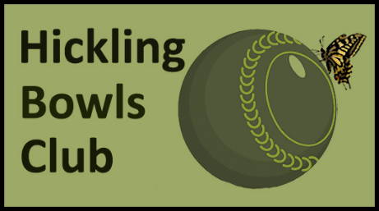 | PROPOSALS FOR THE 2025  CHRIS NUDD CUP  (SEPTEMBER CUP)

- The Chris Nudd Cup is a 3-wood competition open to any member of HBC. Entries need to be confirmed by (date TBA). If insufficient numbers of club members sign up for the competition, invitations will be sent to neighbouring clubs asking them to put players forward. In the first year, invitations will be restricted to Happisburgh, Ludham, Potter Heigham, Repps and Stalham.
- The purpose of the competition is to provide playing opportunities towards the end of the season and to raise funds for the club. The suggested match fee is £3.

- Matches will be played on Friday afternoons, or at other times which do not affect league fixtures. It is hoped to start the competition in mid- to late-August and run through to early September. The start time will depend on the number of entries (it may be possible to hold two lots of doubles matches on one day).

- Teams will be selected by names drawn from a hat by the organisers (J Parsons & I Smith).

- Dress code: Hickling members must wear club colours. Players invited from other clubs may wear their club colours or greys and whites.

- The competition will be played between blocks of four players if there are enough entries (from both Hickling and other clubs). Otherwise the organisers will draw blocks of three players.

- Each block will play one triples match, two doubles matches and two singles matches. In week one, the number of singles matches will be determined by the number of blocks. In week two, the number of doubles matches will be determined by the number of blocks. In week three, triples teams will be selected by the captains.

- Captains: Each block will decide on who is captain. The captain does not have to play in every match, but all players will play at least one match. The captain will toss a coin to decide who has the jack, and he/she will draw the number for the rink.

- 3-wood Rules:
Distance: 23 yards and all bowls in count
Jack live in ditch but all bowls in ditch are dead
If jack goes out of rink, another end must be played
All points gained go towards the team total, and the team with most points wins
In event of a draw on points, the captains select one player for a deciding singles end, adjudicated by an independent observer

