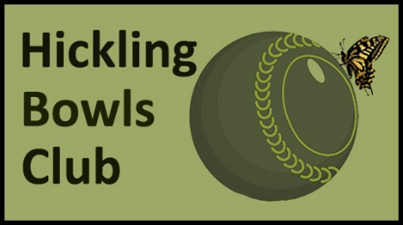 | ANNUAL DINNER  AT THE BOATHOUSE  MENU

THREE COURSES £30 per person - TWO COURSES £25 per person
PLEASE ARRIVE AT 7pm FOR SIT DOWN AT 7.30pm.
(Please note if you do not choose a starter, there will be approximately a 30 minute wait for your main course)
CHOICES FOR STARTERS
1. SOUP OF THE DAY - with white or granary cottage roll
2. BOATHOUSE PRAWN COCKTAIL - with granary croute
3. TEMPURA TIGER PRAWNS - with Asian inspired salad, plum & sweet chilli sauce & fresh lemon
4. HAM HOCK TERRINE - with apple purée, sun dried tomatoes & baby leaves
5. CHILLED ASPARAGUS - with a crispy Panko Hen’s egg, Parmesan cheese & a balsamic glaze.
VEGETARIAN CHOICES FOR MAIN COURSE
1. FIVE BEAN & VEGETABLE BURGER - in a toasted bun with relish, lettuce, tomato, red onion, gherkin, coleslaw and onion rings with A CHOICE OF - Chunky Chips, Sweet Potato Fries, Skinny Fries or Spicy Wedges
2. PANKO COATED HALLOUMI - with mixed salad & tomato salsa with A CHOICE OF Chunky Chips, Sweet Potato Fries, Skinny Fries or Spicy Wedges
3. ASPARAGUS, PEA & BROAD-BEAN TAGLIATELLE - in a white cream sauce with wild garlic oil & vegetarian hard cheese
4. ROASTED MEDITERRANEAN VEGETABLE LASAGNA - with garlic bread & a side salad
GASTRO MENU CHOICES FOR MAIN COURSE
1. SEA BASS - with King Prawn & Clam Linguine, Samphire & a chilli, garlic & parsley butter sauce
2. CHICKEN SUPREME - marinated in Honey, Lemon & Tarragon with creamy Polento, Tender Stem Broccoli, roast cherry tomatoes & Honey & Chilli dressing
3. LAMB RUMP - Roast Lamb Rump, Sauté Potatoes, Asparagus, Tender Stem Broccoli & Wild Garlic Salsa Verde
4. PORK CUTLET - Chargrilled on the bone, Marinated in Sage, Garlic & Lemon with crispy Potato Cubes, Rocket, Cherry Tomato & Parmesan Salad with a Chestnut Mushroom & Peppercorn Sauce
DESERT CHOICES
1. BOATHOUSE SUNDAE - Vanilla Ice Cream, Chantilly cream, brownie nuggets, berry compote, meringue with a CHOICE OF - Raspberry, Chocolate or Toffee Sauce
2. LIMONCELLO TRIFLE - Layered Vanilla Sponge, lemon curd & vanilla custard, topped with Chantilly cream & white chocolate
3. CHOCOLATE FUDGE BROWNIE - with chocolate sauce & vanilla ice cream
4. MANGO CHEESECAKE - with Mango Purée, Chantilly Cream & fresh berries

